**YO-YO DESPINNER EXPERIMENT OPERATIONAL PROCEDURE**

**SET UP:**

Before proceeding with the experiment, confirm the following:

1. Plug in the control box power cord into the lab station power outlet.
2. Connect each of the two grey serial cables; one to the serial port on the control box and the second to the lab station computer serial cable that extends from the wiring access hole.
3. Connect the metallic 15-pin connector cable to the control box (male end) and the other end to the yo-yo despinner module (female end).

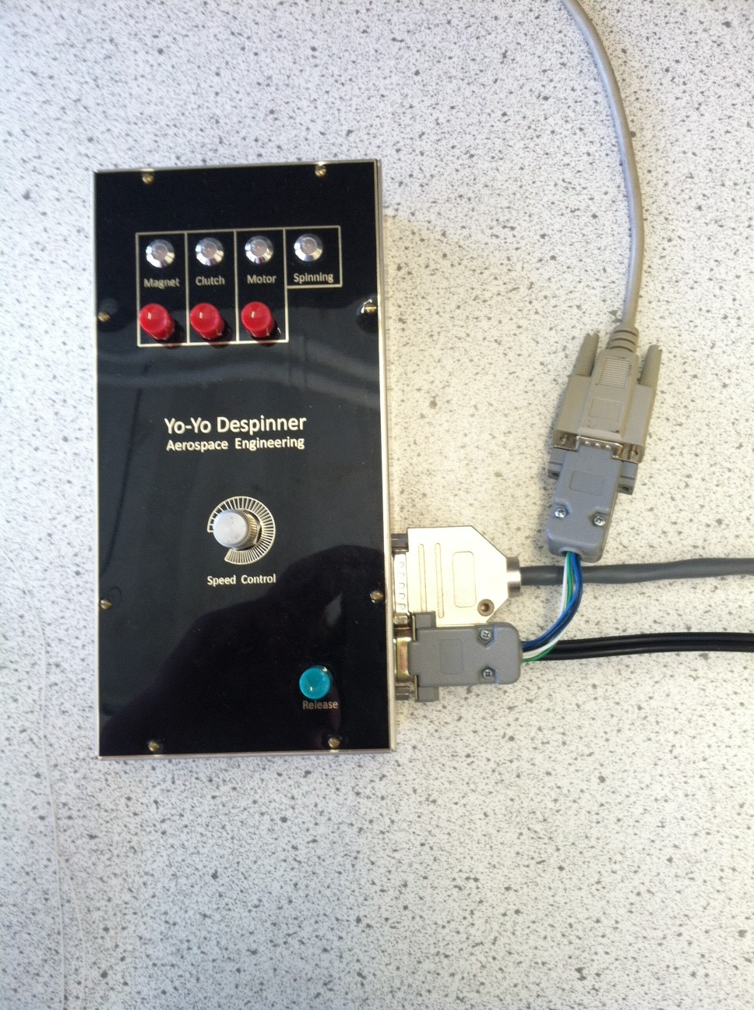

Yo-yo Despinner

Power

Lab Station

1. Open the yo-yo_despinner.vi file from the course folder (H:\Spring 20xx\ASEN2003\Yo Yo Despinner).
2. Ensure the speed control is set to “0” (all the way counter-clockwise) and turn on the control box power with the switch on the upper-right corner (all lights should illuminate red).

**OPERATING PROCEDURE:**

1. If desired, select the AutoZero button to set speed values that drop below 20 rpm for 10 iterations to zero. This is a feature added since the encoder cannot calculate velocity at low speeds.
2. Turn ON the electromagnets by pressing the “Magnet” button on the control box (the magnet light should illuminate green).
3. Attach desired weights, if necessary, to spinner magnets. For best results, use the hexagon shaped masses. Insert nylon capture ball into attachment mechanism located on spinner side. Pull tether string fairly taut and wrap around the cylinder. Adjust ball capture mechanism as needed to accommodate string length. (String should wrap counter-clockwise.) DO NOT allow the string or knots to catch in the slot or other mechanisms. Use the head of the steel flathead screw protruding from the brass hexagon masses to align the flat ferrous surface with the electromagnets on the satellite.
4. Tighten ball capture mechanism in place using nut. Repeat for other weight. Notice attachment piece is offset to best align with either top and or bottom magnet. Limit string lengths to one cylinder wrap or less to avoid tangles.
5. Place the Despinner mock spacecraft unit under the safety net.
6. Confirm safety net is fully deployed including wooden 2x4’s holding net against lab floor. Ensure there are no holes in net or gaps at the bottom that the strings and masses could fly out of.
7. Confirm all nearby lab users are wearing safety glasses. Use caution, on rare occasions the weights can still fly through the net. DO NOT stand directly beside the net when the weights are released.
8. Turn ON the clutch by pressing the “Clutch” button on the control box (the clutch light should illuminate green).
9. Activate the motor by pressing the “Motor” button on the control box (the motor light should illuminate green).
10. Start the VI by pressing the arrow in the top left corner.
11. On the control box, slowly turn the “Speed Control” knob CW and observe spinner rotating**.** Set desired RPM, but **DO NOT** exceed 110 RPM. Wait for system to stabilize (~1 minute). The speed control algorithm is course, if the speed changes, be patient, give the control time to re-stabilize and then take data.
12. Push “Release” button to detach weights. Once the speed levels off, (the speed will not reach exactly 0 RPM since the VI can’t read below 5 RPM) press the “Stop and Save” button and save your data.
13. Turn the “Speed Control” knob back to zero (CCW). Repeat test as necessary.

Last Updated: 4/4/17

Mars Exploration Rover 2003 Animation showing Yo-Yo Despinning:

<http://www.youtube.com/watch?v=-_9BYSDtwRc> (yo yo is at ~1:58 min)

